## What is Selenium

Selenium is one of the most widely used open source and a portable automated software testing Web UI (User Interface) testing tool for testing web applications. It was originally developed by Jason Huggins in 2004 as an internal tool at Thought Works. Selenium supports automation across different browsers, platforms and programming languages.

It has capabilities to operate across different browsers and operating systems. Selenium is not just a single tool but a set of tools that helps testers to automate web-based applications more efficiently.

# Components of Selenium

Selenium is not just a single tool but a suite of software, each with a different approach to support automation testing. It comprises of four major components which include:

1. Selenium Integrated Development Environment (IDE)
2. Selenium Remote Control (Now Deprecated)
3. Web Driver
4. Selenium Grid

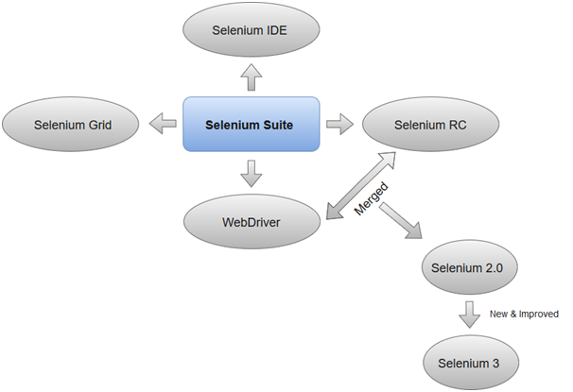

### 1.Selenium Integrated Development Environment (IDE)

Selenium IDE is implemented as Firefox extension which provides record and playback functionality on test scripts. It allows testers to export recorded scripts in many languages like HTML, Java, Ruby, RSpec, Python, C#, JUnit and TestNG. You can use these exported script in Selenium RC or Webdriver.

### 2. Selenium Remote Control

Selenium RC allows testers to write automated web application UI test in any of the supported programming languages. It also involves an HTTP proxy server which enables the browser to believe that the web application being tested comes from the domain provided by proxy server.

Selenium RC comes with two components.

1. Selenium RC Server (acts as a HTTP proxy for web requests).

>

1. Selenium RC Client (library containing your programming language code).

The figure given below shows the architectural representation of Selenium RC.

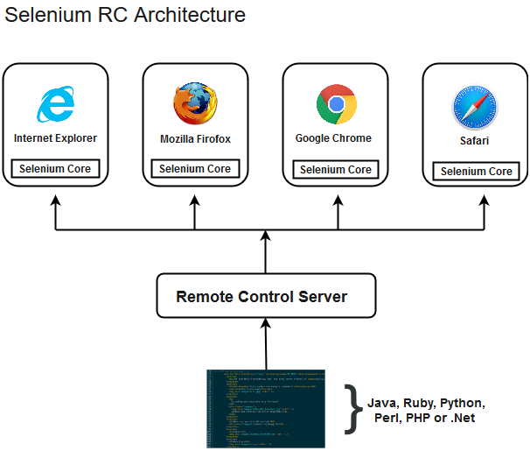

### 3. Selenium WebDriver

Selenium WebDriver (Selenium 2) is the successor to Selenium RC and is by far the most important component of Selenium Suite. SeleniumWebDriver provides a programming interface to create and execute test cases. Test scripts are written in order to identify web elements on web pages and then desired actions are performed on those elements.

Since, WebDriver directly calls the methods of different browsers hence we have separate driver for each browser. Some of the most widely used web drivers include:

* Mozilla Firefox Driver (Gecko Driver)
* Google Chrome Driver
* Internet Explorer Driver
* Opera Driver
* Safari Driver
* HTML Unit Driver (a special headless driver)

### 4. Selenium Grid

Selenium Grid is also an important component of Selenium Suite which allows us to run our tests on different machines against different browsers in parallel. In simple words, we can run our tests simultaneously on different machines running different browsers and operating systems.

## Selenium Features

Let’s discuss the features of Selenium one by one.

### 1. Multi-Browser Support

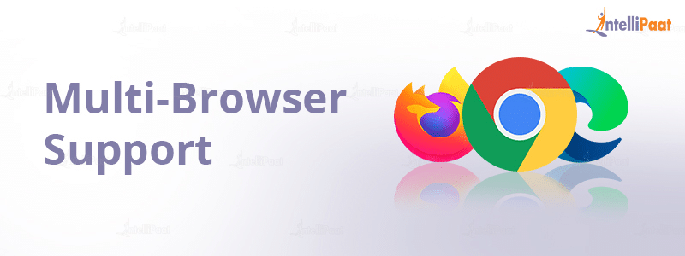

Selenium is capable of interacting with web apps and the web elements in a browser just like a real user would. Selenium does that by using a browser native support that makes direct calls without the use of any intermediary device or software. Almost all browsers are supported by Selenium – Chrome, Safari, IE, Opera, Edge, and Firefox.

### 2. Multi-Language Compatibility



Selenium supports almost all programming languages like PHP, Java, Python, JavaScript, Perl, Ruby, etc. You can write automation test scripts using any programming language you feel comfortable with. You can also use switch statements, conditional statements, or decision-making statements to enhance your automation test script. This step will make your test script capable of handling all kinds of situations.

### 3. Easy Identification and Use of Web Elements

Selenium makes it easy to identify web elements on the web apps with the help of its several locators. This makes the implementation of the elements much easier in the test automation suite. There are various [***Selenium IDE***](https://intellipaat.com/blog/tutorial/selenium-tutorial/selenium-ide/) you can add to your web via extensions.

### 4. Performance and Speed

Selenium has a particular component for the automation of web app testing called WebDriver. This tool is able to execute test cases quicker than the other tools. It is capable of communicating directly with the browser so there is no requirement for intermediaries like the server.

### 5. Dynamic Web Elements

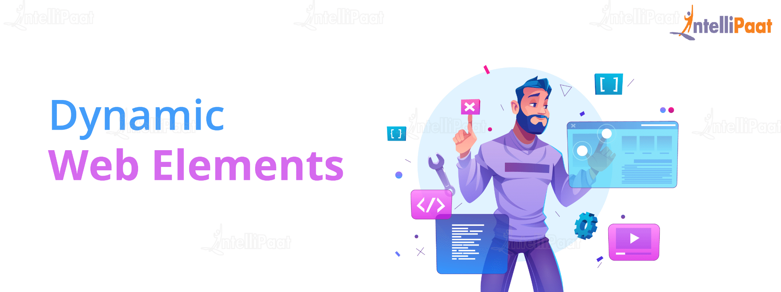

Selenium is capable of handling dynamic web elements with ease. It utilizes some of the following methods to do that:

* **Contains():** You can use a partial text to find an element.
* **Absolute XPath():** This XPath can easily handle dynamic web elements. It comes with a complete set of paths for web UI automation, right from the root node.
* **StartsWith():** This function helps find an attached attribute to a dynamic web element by matching or finding the starting text.

### 6. Open Source

Selenium is open-source software. It can be easily downloaded from the official Selenium website.

### 7. Portability (Ability to work with different Operating Systems)

Selenium is portable software. It can work with different Operating Systems like Linux, Mac, UNIX, and Windows.

### 8. Take less time to execute a test

Selenium reduces the test execution time. This helps make the execution more reliable and faster.

### 9. Server installation is not required

You don’t need to install a server for Selenium. Selenium can interact directly with the browser.

### 10. Lesser resources required

Selenium requires lesser resources when compared to its competitors like UFT, RFT, etc.

**Drawback of Selenium**

* **Incomplete solution –** Selenium requires third-party frameworks in order to completely automate the testing of web applications.
* **Requires high skills –**Though it supports multiple programming languages, it requires a high-level proficiency to deal with it effectively.
* **Hard to modify codes –** The scripts written in Selenese are not user-friendly which makes it hard to modify the codes.
* **Tougher to support other browsers –** Selenium faces difficulties when trying to implement in any browser other than Firefox.

# What are different selenium versions?

[Selenium](https://www.tutorialspoint.com/articles/category/selenium)[Automation Testing](https://www.tutorialspoint.com/articles/category/automation-testing)[Testing Tools](https://www.tutorialspoint.com/articles/category/testing-tools)

**Selenium 1** or known as RC (Remote Control) As name suggest, RC is a Remote Control which works by taking the remote of the browser and then injects the automation code to be tested by injecting the custom scripts written.

The Web Driver (known as Selenium 2) works on the browser directly and uses browsers in-built features to trigger the automation test written by tester. Web driver is the successor of Remote Control.

The architecture of Selenium Web driver is as follows -

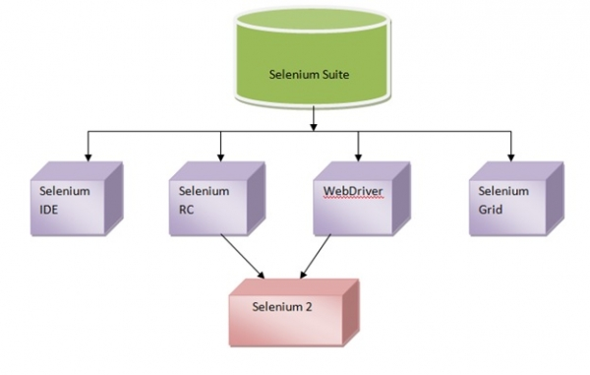

**Selenium 2**  is nothing but integration of Web Driver with Selenium RC (Selenium1). Selenium 1 is a well-established framework which supports various many browsers due to its JavaScript implementation. To step out of JavaScript Sandbox, Web Driver is developed for each browser which provides headless browser emulator which is very speedy. The strengths of both Web Driver and Selenium 1 are imbibed in Selenium2 which also helps in getting rid of their respective drawbacks.

**Selenium 3** For users of Web Driver API’s this is drop-in replacement. The major change being, removing core and replacing it with back-end Web Driver. Selenium 3.0 has become a W3C (worldwide web consortium) standard. Also, Selenium 3 would be majorly looking to be a choice of software testing tool for both web and mobile based applications.